Paper Title (Times New Roman 14pt, Centered, Before 0pt, After 5pt)
Main Author (Full name without title, Times New Roman 11pt, Before 5, After 3pt)
Author's Full Address, E-mail: firstauthor@email.com
Second Author (Full name without title, Times New Roman 11pt, Before 5, After 3pt)
Author's Full Address, E-mail: author@email.com

^{(blank space for distance)}
Abstract
This section must be written in English. Use 10 pt Times New Roman font, single spacing, italics, with 5 pt spacing before and after the paragraph. The abstract must not exceed 200 words.
Keywords: Use 10 pt Times New Roman, Italic, Space before 5 and Space after 5, Alphabetically, Capitalized each word.

Introduction
Each chapter title should use Times New Roman font, size 12, bold, in capital letters, with 5 pt spacing before and after the paragraph. For the body text, use Times New Roman font, size 10, with single spacing (Text style). To format each section of the paper correctly, it is recommended to use this template file and follow the instructions provided in Chapter 2.

Layout, Style and Format
This review paper uses custom margins: Top, bottom, left, and right 2.5 cm. The gutter is positioned on the left. The page orientation is Portrait. The paper size is A4. The styles available and used in this paper are:
- Paper Title, for the paper title
- Writer, for the author's name (main author and additional authors)
- Address, for author addresses (main author and additional authors)
- Abstract Title, for Abstract Titles
- Abstract Contents, for the content of the Abstract
- Keywords, for Keywords
- Heading 1, for Chapter Title
- Heading 2, for Chapter Sub-Titles
- Heading 3, for sub-Sub Chapter Titles
- Text, for Text content
- Formula, for mathematical formulas
- Picture, for Image description
- Table, for Table description
- References, for References
This template is provided for all papers submitted to the International Postgraduate Conference on Civil Engineering (IPCCE). In the "Style and Formatting" menu, simply apply the appropriate style by selecting the style name from the Style menu box, as shown in the image below. To simplify the writing process, you can replace the content in this file (via copy-paste).

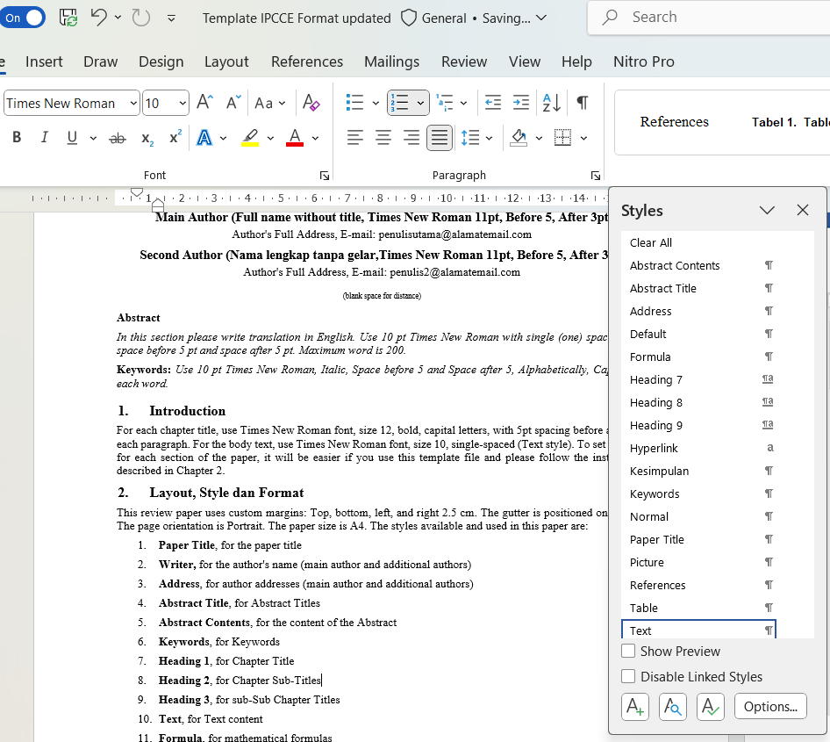

Mathematical Formula
Mathematical formulas should be written using the Equation Editor in MS Word. Formulas must be in 10 pt font, indented by 1.27 cm, and numbered sequentially starting from (1), aligned to the right. To apply this style, select 'Formula' from the Style box or Style menu. Please note that this style only sets the tab stop positions. To align the formula number to the right, press the Tab key once. To increase the spacing between the formula and its number, press the Tab key again from the right side of the formula.
$M_{p}=F_{y}Z$ (1)
For formula numbering, use sequential numbers (1), (2), (3), etc. Do not use formulas based on Chapters such as (2.1), (2.2), (3.1) etc. To refer to formulas in the text, use the sentence Equation (1).

Chapters and Sub-chapters
Use Heading 1 for chapter titles, Heading 2 for sub-chapter titles, and Heading 3 for sub-sub-chapters. The numbers will be assigned automatically.

Figures and Tables
All figures and tables must be numbered consecutively (numbering is automatic if you use the Figure and Table styles provided in this file). Figure and table numbers are not based on chapter or subchapter numbers. Use the Figure and Table styles for each respective description. Ensure that images are clear and sharp, as this significantly impacts the print quality.
In the text, figures are cited in bold and the figure or table number is used. For example, "The location map can be seen in Figure 1, with the legend in Table 1”.

Picture
- Image descriptions should be written in Arial 9 pt, bold, and centered. Select the 'Picture' style from the Style menu. Only the first letter of the first word in the title should be capitalized. (Include a source if the image is taken from another work, e.g., Popov and Engelhart, 1988).
Table descriptions should be written in Arial 10 pt, bold, and numbered sequentially. The following is an example of a table and its description. The table does not use vertical lines and is positioned flush with the left and right margins (justified). Column headers are in bold.
- Loading patterns on EBF links and portals
No | Segments | Length  (km) | Elevation  (meter)
1 | A-B | 25 | 30
2 | B-C | 75.15 | 10
3 | C-D | 44.75 | 50
4 | D-E | 72.5 | 10
5 | E-F | 21.25 | 10
Descriptions of Figures and Tables do not end with a period “.”.

Paper Length and Content
The paper length is maximum 12 pages. Includes images, tables, nomenclature, references, etc.
The contents and order of the paper must follow the following rules:
- Paper Title
- Author's name and address
- Abstract and Keywords (in Indonesian and English)
- Chapter structure (Introduction ..... Conclusion), avoid writing chapter structures like a thesis or dissertation.
- Acknowledgments (if any)
- Bibliography
Specifically for conclusions made in the form of points, an example can be seen below:

Conclusion
- Conclusion A.
- Conclusion B.
- Conclusion C.

Citations and Bibliography
In the text, bibliography citations with one or two people use the last name of the author and the year taken from the Bibliography, for example: "the results of Arce's calculations (2002)......", "....according to Kasai and Popov (1986)......". If there are more than two authors, then it is written as "et al", for example: "....based on the research results of Gobharah et al (1991)......".
The bibliography should be written in Times New Roman 10 pt font, with a hanging indent of 1 cm, 5 pt spacing before and after each entry, and arranged alphabetically.
Generally, the author's last name is written first, followed by the abbreviation of their first name. If there are additional authors, follow the same format. This is followed by the publication year, the article title (in bold), the journal or book name (in italics), the volume number (followed by a colon ":"), and finally the page number, ending with a period. See the examples below:

References
American Institute of Steel Construction 341-2010, Seismic Provision for Stuctural Steel Building, AISC, Inc. (example from the book)
Arce, G., 2002, Impact of Higher Strength Steels On Local Buckling and Overstrength of Links in Eccentrically Braced Frames, MS Thesis, USA: Univ. of Texas at Austin. (example from a thesis/dissertation)
Bruneau, M., Uang, C.M., Sabeli, R., 2011, Ductile Design of Steel Structure, McGraw-Hill. (example from textbook)
Kasai, K., dan Popov, E.P., 1986b, General Behavior of WF Steel Shear Link Beams, Journal of Structural Engineering, ASCE, Vol. 112, No.2, 362-382. (example from Journal)
Okazaki, T., Engelhardt, M.D., 2006, Finite Element Simulation of Link-to-Column Connection in Steel Eccentrically Braced Frames, Proceeding of the 8th U.S. National Converence on Earthquake Engineering, San Fransisco, California, USA., April 18-22, paper No.1526. (example from conference proceedings)
SNI 03-1729-2002, Tata Cara Perencanaan Struktur Baja Untuk Bangunan Gedung. (example from Code)

